## Creating a Virtual Machine via the Azure Portal

This lab will walk you through creating a virtual machine in Azure by using the web portal. For one-time usage, or for learning about new features, this works well. For a repeatable process, you’ll want to automate your deployments by using PowerShell and Azure Resource Manager (ARM) Templates. For now, let’s log on to the Azure Portal as we did in the first look section and create a virtual machine

1. Click new …

Make sure that the Deployment Mode is set to Resource Manager then click Create

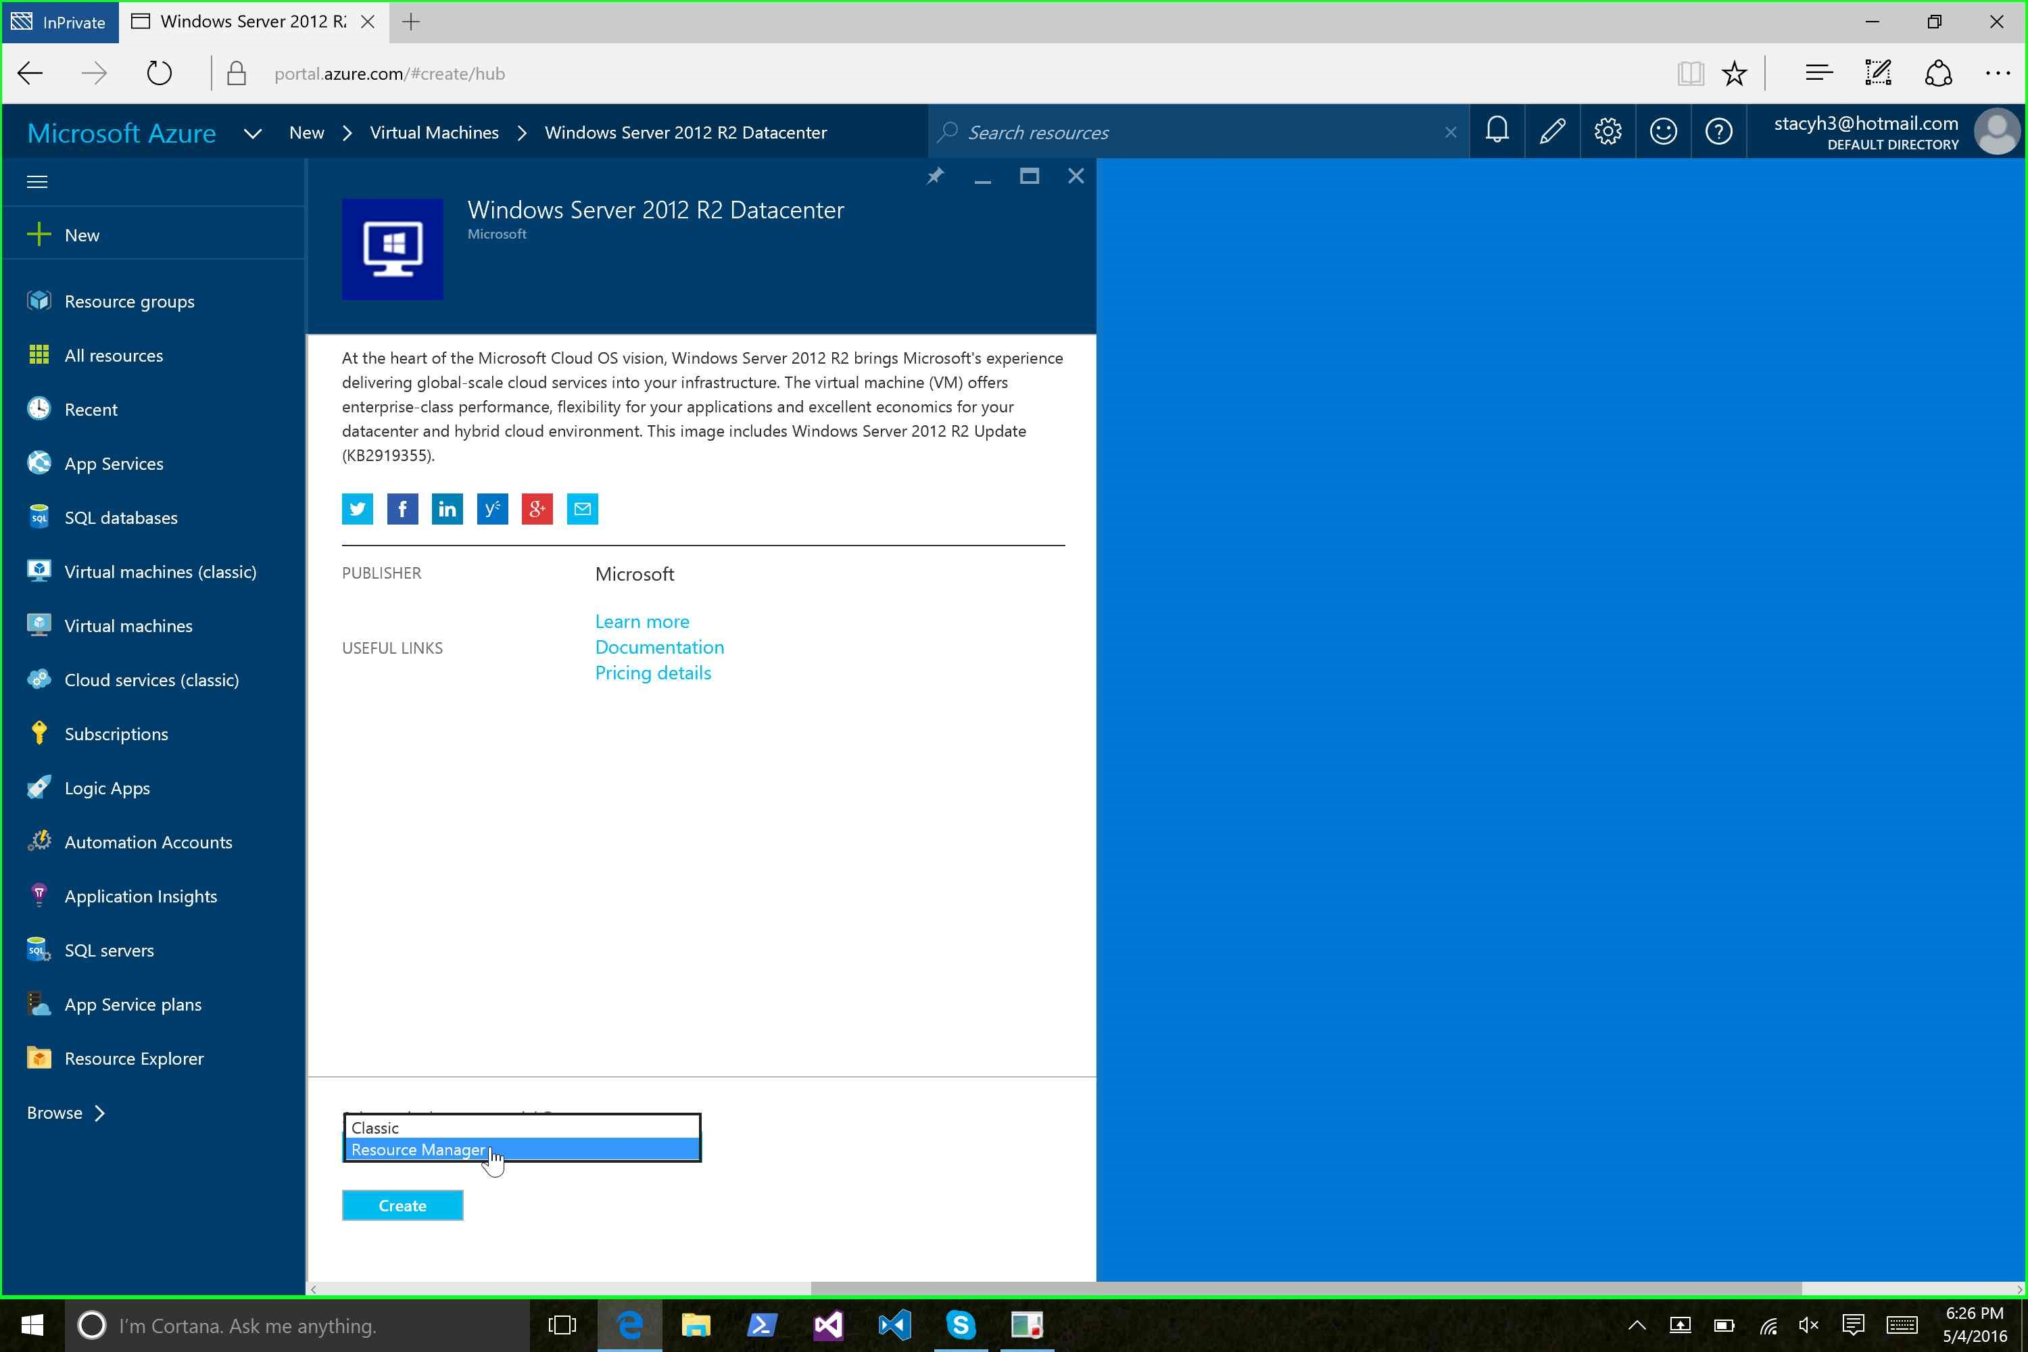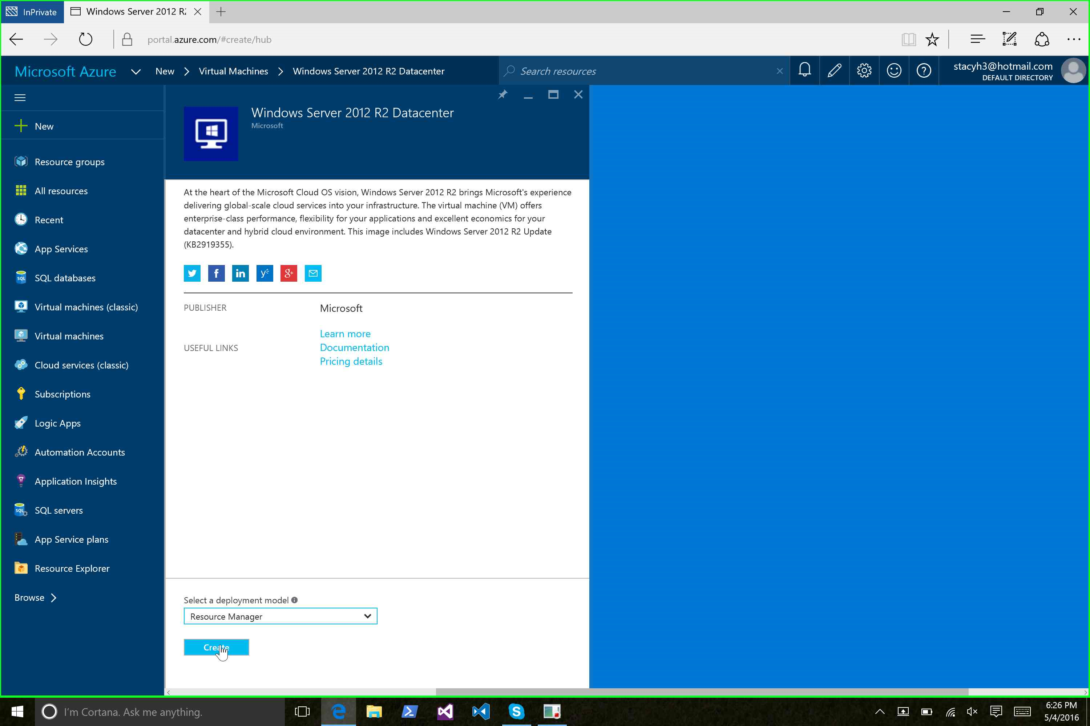

In the next series of steps, we’ll build up the VM and the other environmental components that it needs. First, let’s supply some basic information:

* Name: The name of the Virtual Machine
* User Name: The name for the administrative user account on the Virtual Machine
* Password: The password for the administrative user account on the Virtual Machine
* Subscription: If you have multiple Azure subscriptions, you can choose which subscription to use for this deployment
* Resource Group: The name of the Resource Group into which the Virtual Machine will be deployed
* Location: The data center where your resources will be deployed

